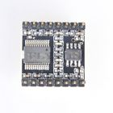**MP3 Player Module Sound Module with Simplified Output Speaker for Arduino/UNO**

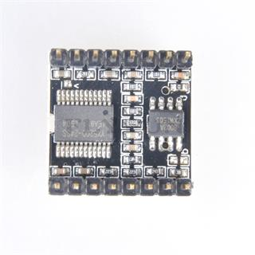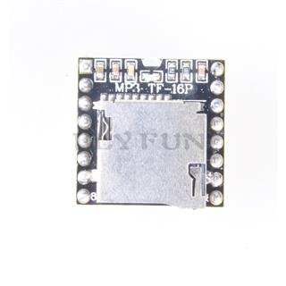

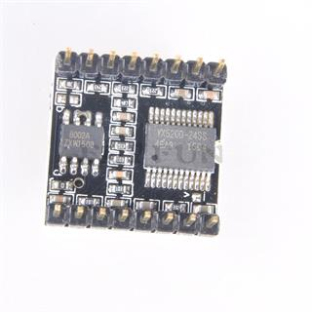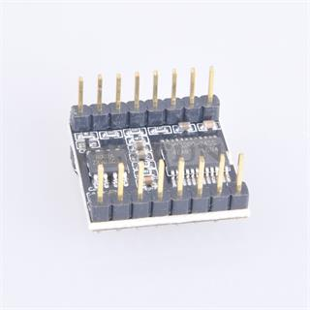

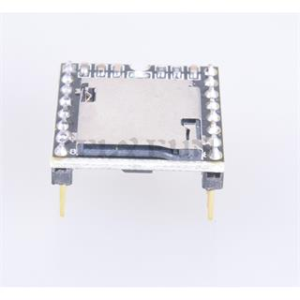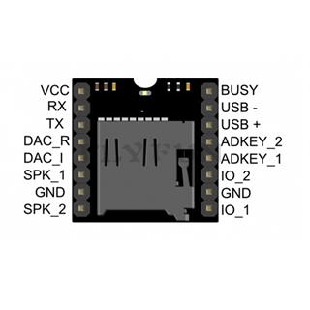

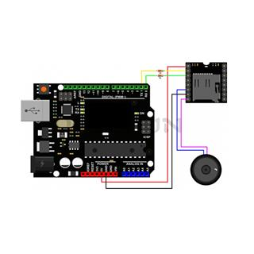

## **Description**

Sing for the moment! The DFPlayer Mini is a small and low cost MP3 module with an simplified output directly to the speaker. The module can be used as a stand alone module with attached battery, speaker and push buttons or used in

combination with an (for)Arduino (for)UNO or any other with RX/TX capabilities.

It is perfectly integrates hard decoding module, which supports common audio formats such as MP3, WAV and WMA. Besides, it also supports TF card with FAT16, FAT32 file system. Through a simple serial port, you can play the designated

music without any other tedious underlying operations.

**APPLICATIONS:**

Car navigation voice broadcast;

Road transport inspectors, toll stations voice prompts;

Railway station, bus safety inspection voice prompts;

Electricity, communications, financial business hall voice prompts;

Vehicle into and out of the channel verify that the voice prompts;

The public security border control channel voice prompts;

Multi-channel voice alarm or equipment operating guide voice;

The electric tourist car safe driving voice notices;

Electromechanical equipment failure alarm;

Fire alarm voice prompts;

The automatic broadcast equipment, regular broadcast.

**SPECIFICATION:**

Supported sampling rates (kHz): 8/11.025/12/16/22.05/24/32/44.1/48

24 -bit DAC output, support for dynamic range 90dB , SNR support 85dB

Fully supports FAT16 , FAT32 file system, maximum support 32G of the TF card, support 32G of U disk, 64M bytes NORFLASH

A variety of control modes, I/O control mode, serial mode, AD button control mode

Advertising sound waiting function, the music can be suspended. when advertising is over in the music continue to play

Audio data sorted by folder, supports up to 100 folders, every folder can hold up to 255 songs

30 level adjustable volume, 6 -level EQ adjustable

**Document:** If you need it, please contact with us

**Package Included:**

1 X MP3 Player Module